Lesson 02 Lesson-End Project

Implement a Stored Access Policy

Project Agenda: To implement a stored access policy

Description: You have been given a project to create a storage account and a container inside it. Once the containers are created, you need to create a stored access policy to get more control over service-level shared access signatures(SAS).

Tools required: None

Prerequisites: None

Expected Deliverables: Add a screenshot showing the storage account with the access policy created.

Steps to be followed:
- Create a storage account
- Create a container inside the storage account
- Set the access policy on the container

Step 1: Create a storage account

- Go to the Azure portal, and in the search bar, type and select Storage accounts

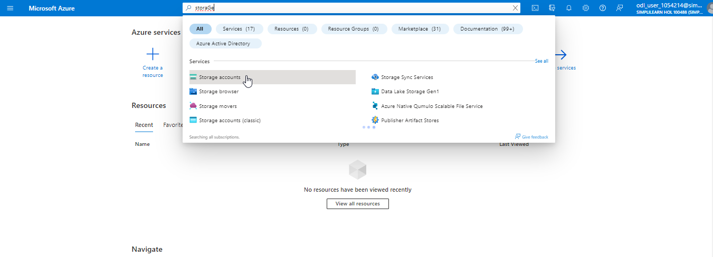

- Click on Create, fill in the Basics tab, and click on Review and Create

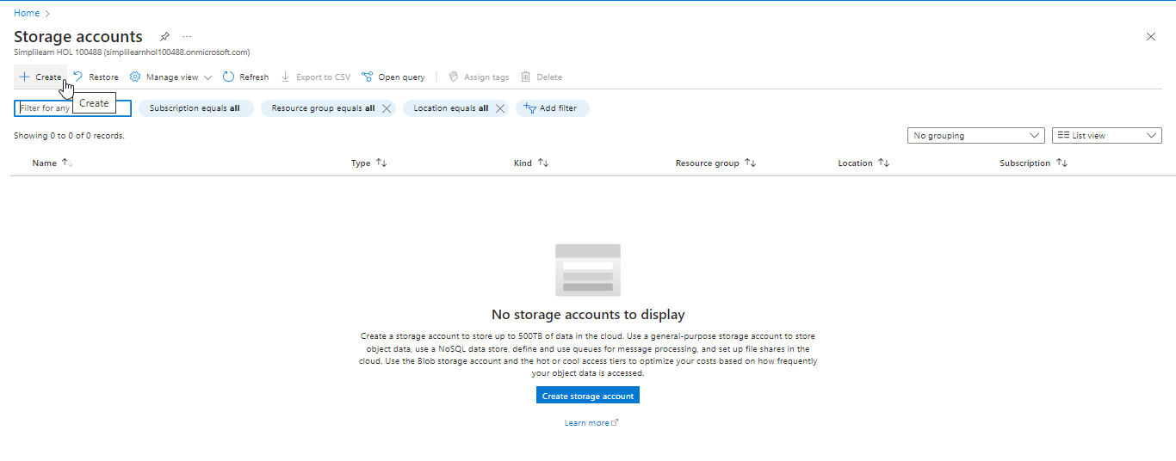

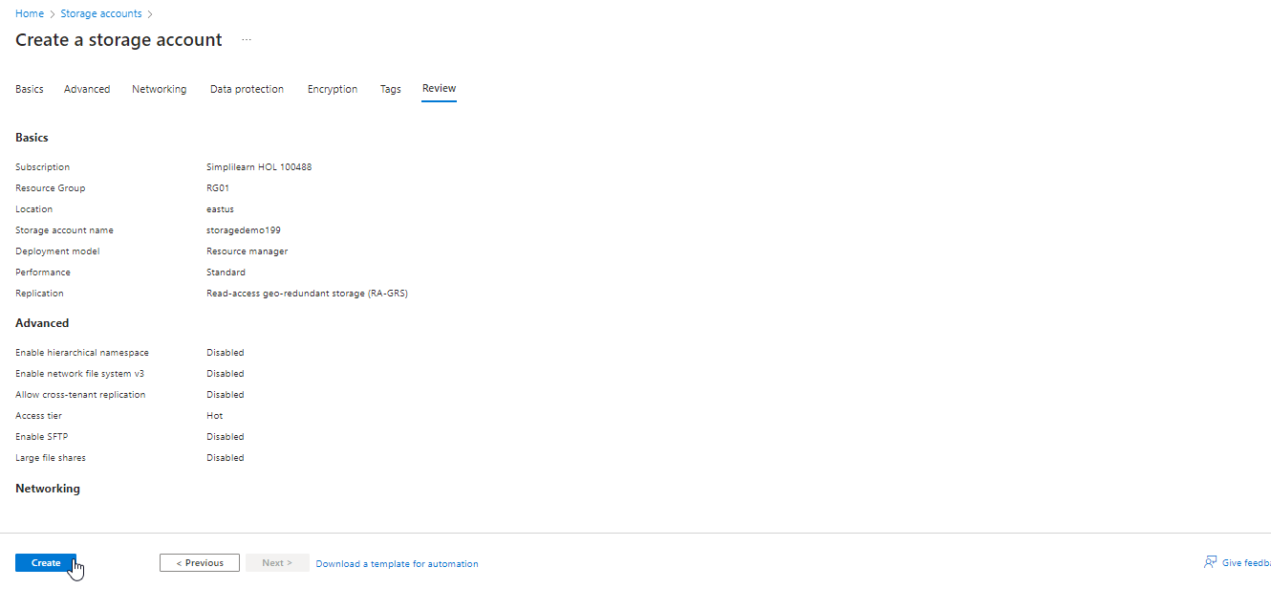

The output will look as follows:

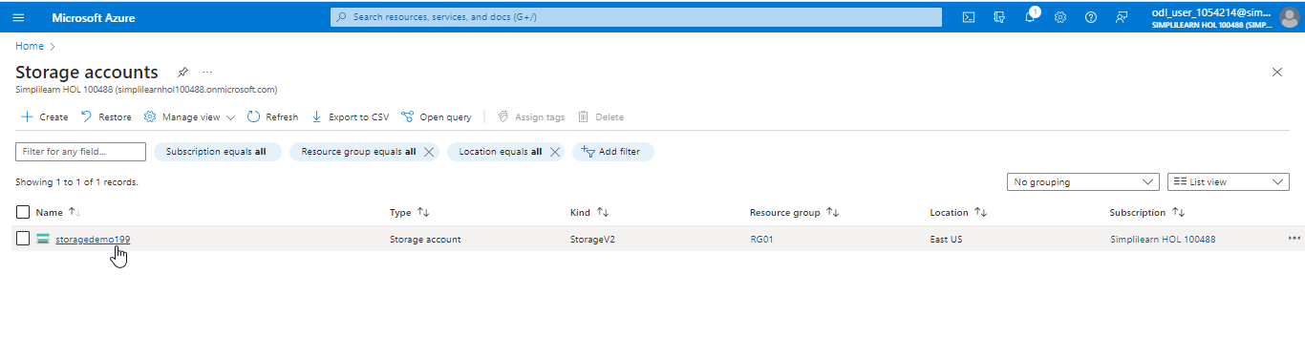

Step 2: Create a container inside the storage account

- Navigate back to the storage account that was created earlier



- Click on Containers under Data storage from the left menu

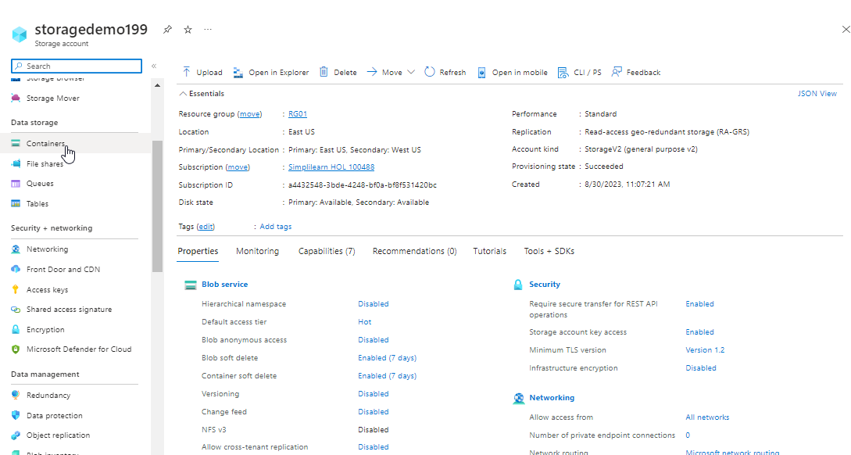

- Click on the Container, fill in the New Container tab, and click on Create

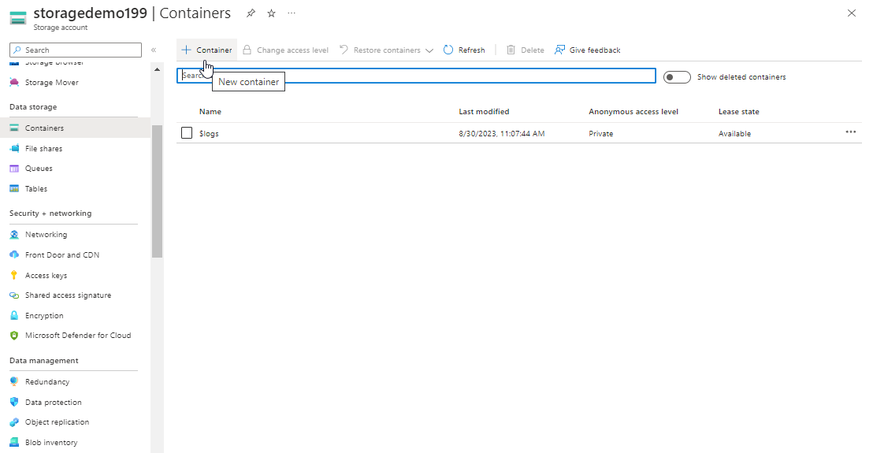

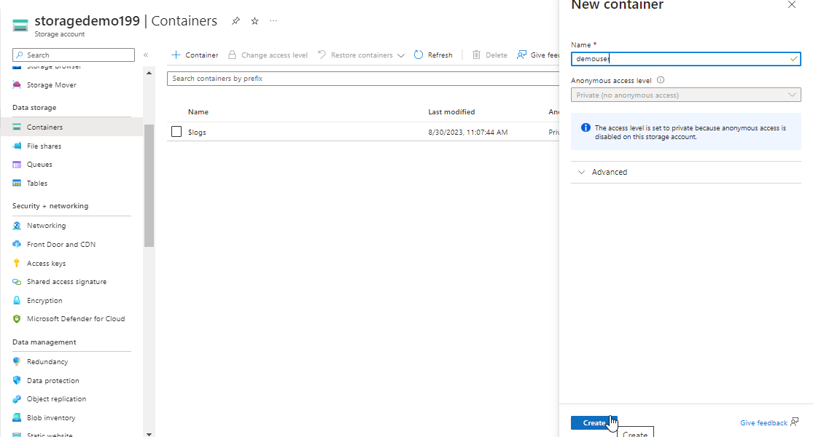

The output will look as follows:

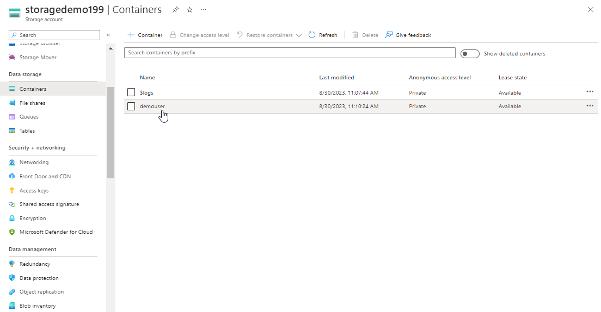

Step 3: Setting the access policy on the container

- Right-click on the newly created container and click on Access policy

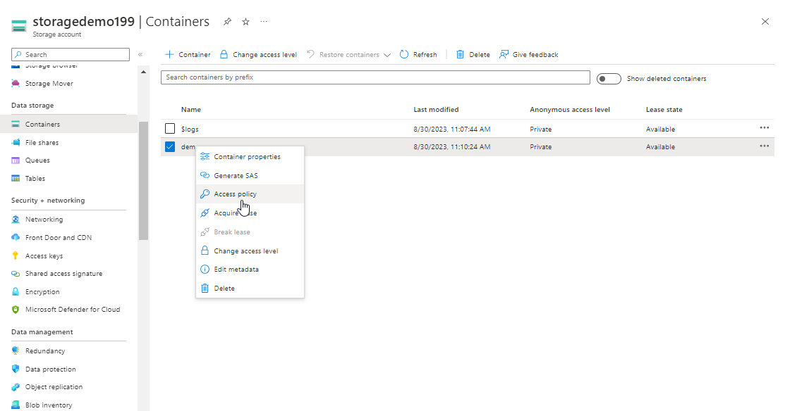

- This will bring the user to the Access policy panel. Next, click on the Add policy button.

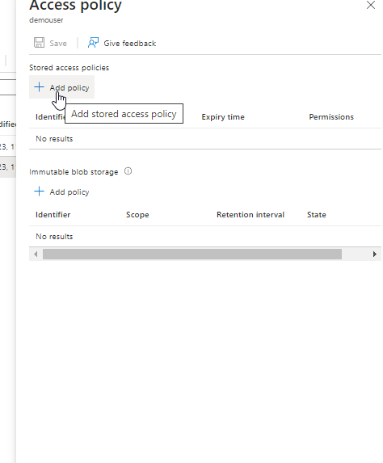

- After clicking on Add policy, users can specify the Identifier, Permissions, Start time, and Expiry time. Once the user fills in all this information, click OK, and a policy will be created.

- Identifier: A string name to identify the policy
- Permissions: A checked list box where the user can select the required permissions
- Start time: The date and time, including time zone, at which the policy will come into effect
- Expiry time: The date and time, including the time zone, at which the policy will be terminated

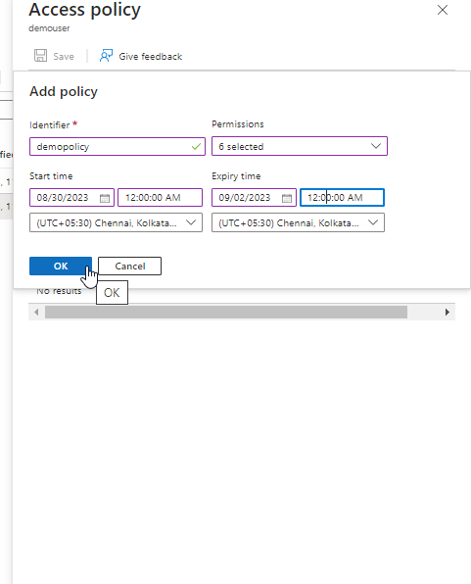

You have now successfully created a storage account and container within and a stored access policy to have more control over service-level shared access signatures (SAS).

